**Problems on git/github and the solutions**

1. Git doesn’t track the local branch with that on remote (among the possibilities might be because the remote is of a different name than local or it had been changed from the previous one)

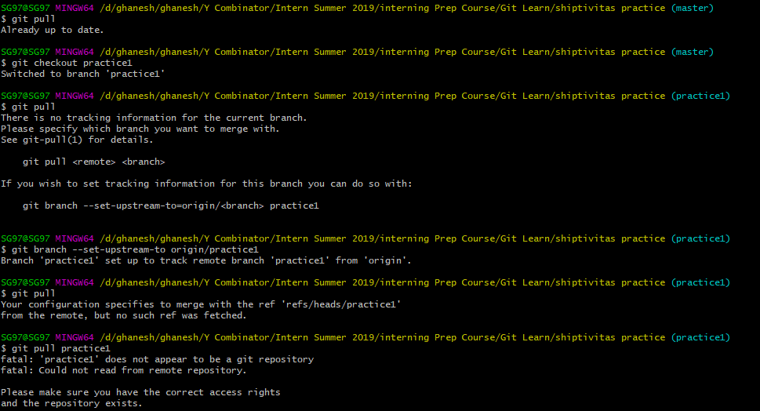

Solution

<https://stackoverflow.com/questions/36984371/your-configuration-specifies-to-merge-with-the-branch-name-from-the-remote-bu>

The answer that worked for me



1. 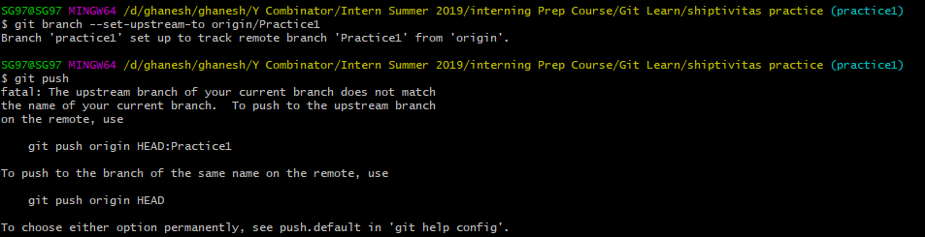Git Push to non-master branch doesn’t work

Solution:

<https://stackoverflow.com/questions/24864700/fatal-the-upstream-branch-of-your-current-branch-does-not-match-the-name-of-you>

The answer that worked for me

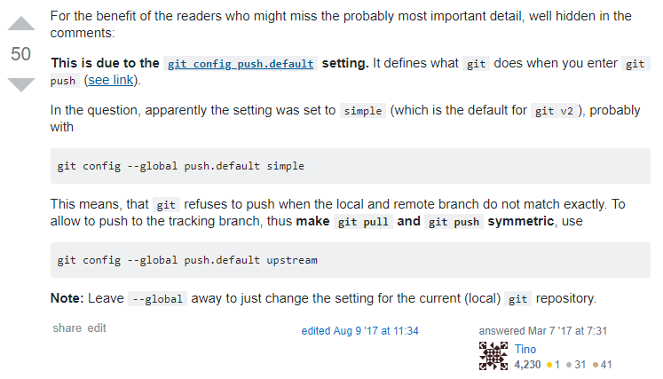

What it looked like on my terminal

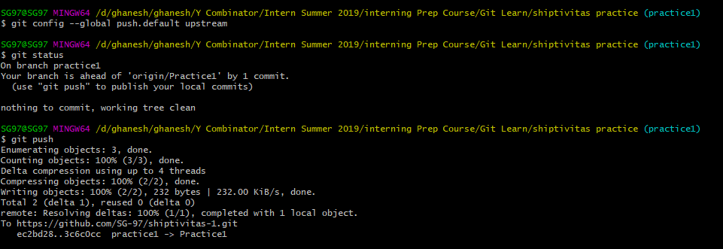

1. Pushing a repo folder that has another folder being used as a repo for another project

*Cannot use .gitignore because there is repo folder within repo folder

*Cannot rm -rf –cached that specific folder also

*repo folder = folder where git bash was run (embedded git repository)

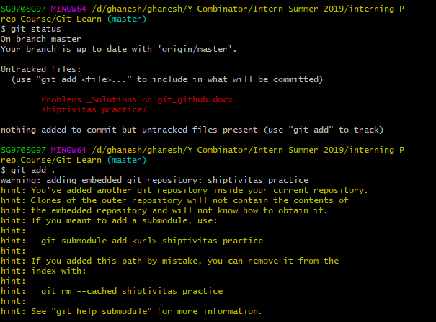Error shown (shiptivitas practice is the repo folder within this repo folder):

Solution:

<https://git-scm.com/book/en/v2/Git-Tools-Submodules>

*For me, I couldn’t add folder DbConnector or any folder name for that matter. When I removed the DbConnector part, it didn’t show ‘fatal’ message

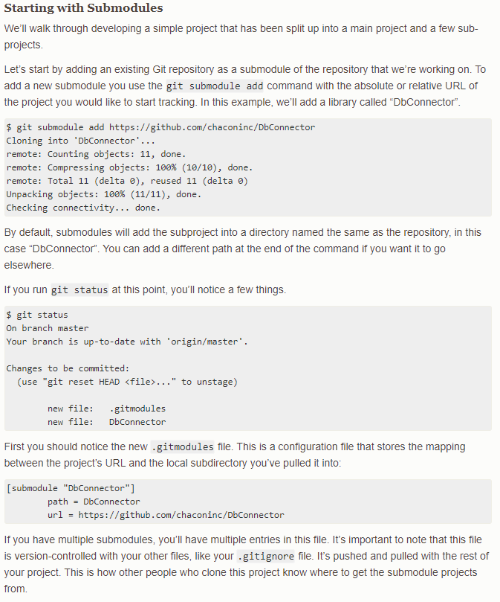

How it looked like on my terminal:

